Micro$oft
Windies Twa Thoosan’ ®
(‘Weegie Edition)
Hullawrerrr ! Micro$oft wants to help YOU in ‘Weegieland. Don’t be forced to use confusing Englified software apps. Due to be release before the Fair Fortnight, the ‘Weegie Edition of Windows 2000, entitled Windies Twa Thoosan’ ® will hit the Barras.

Feel at ease straight away !.
The traditional “Start” button has been replaced with a more familiar term

The “Recycle Bin” has been renamed something more fitting

While the “Internet Explorer” now has a more recognisable title:

Nae mair high fallootin names like “My Documents”. Windies Twa Thoosan’ tells it like it is

An’ “C:\ drive” (wits that then ?) is now called something a wee bit mair appropriate

“Yes”, “No” & “Cancel” are no longer used.

Several exclusive programmes have been included with Windies Twa Thoosan’

The cullurin in book lets ye dae yer ain picters.
Sums lets ye add things up an’ gies ye the rite anser,
an’ the tipe riter lets ye tipe letturs tae yer cronies ( ‘n’ it even cheks yer spelin ).

The computer no longer makes you click an American “OK” but a proper ‘Weegie “Aye.. aw right”

If ye dinna ken how tae dae somethin’ the “Help” facility has been replaced with a more ‘Weegie friendly version

The “Control Panel” now has a new name along with some internal settings.
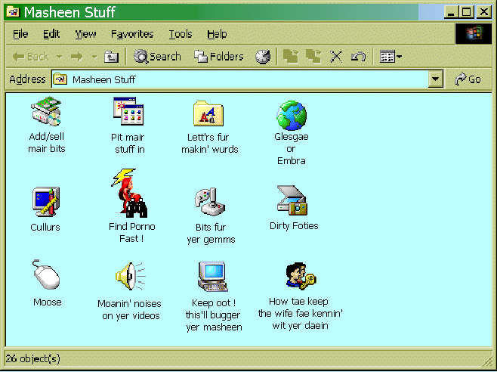

Tips for ‘Weegie users:
If you make a typing error, use the backspace to replace the “wrang yin” ~ Note: Tippex® is hard to clean off the monitor !
After visiting the porn sites for educational purposes, remember to use Kleenex to wipe the keyboard (typewriter bit) clean.

Get yer ane copy the day
Available the noo at the Barras
Only twa weeks dole money.

(free bar o’ soap fer every ‘Weegie !)

