STOP!

First have a look at this picture: police check!

Then read the remaining text at the bottom of this page…

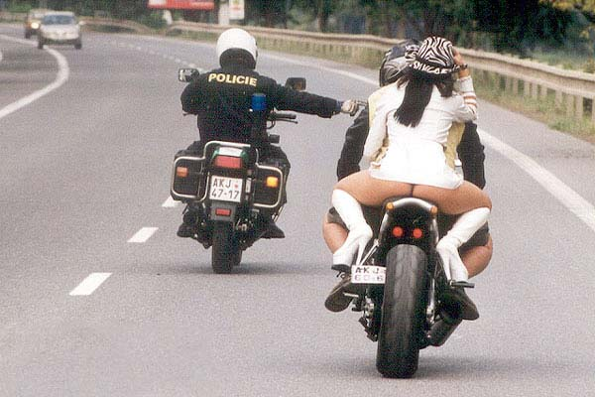
.
.
.
.
.
.
.
.
.
.
.
.
.

.
.
How long did it take you to notice that the girl is not wearing a helmet?

