Cool art that will mess with your head
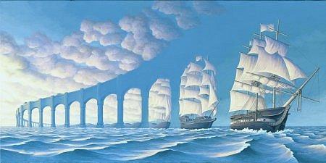

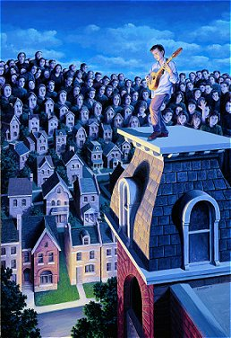

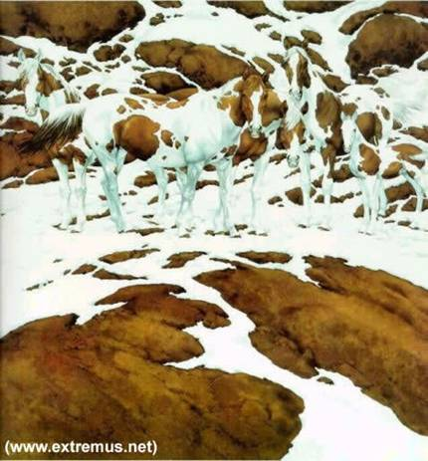
How many horses in this picture? Should find 7
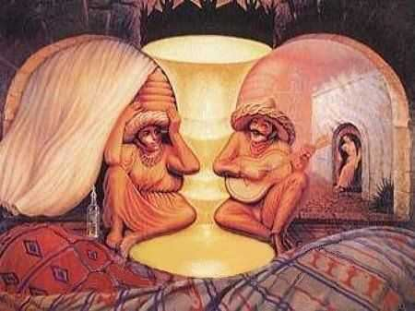

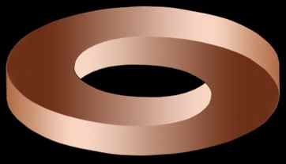

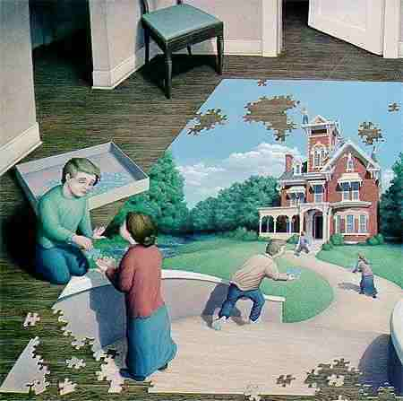

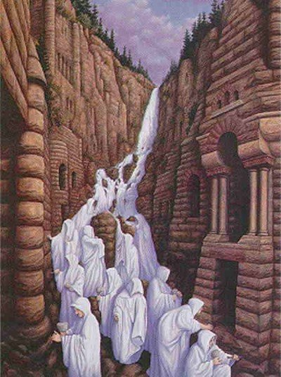

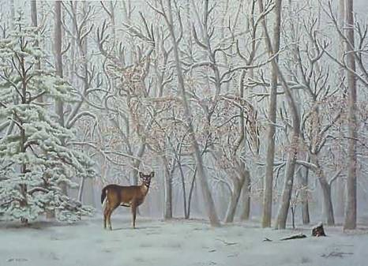

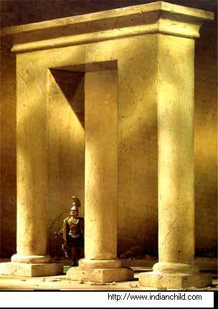
Look at the middle column.
Where does it end?

DO YOU SEE FOUR PEOPLE?
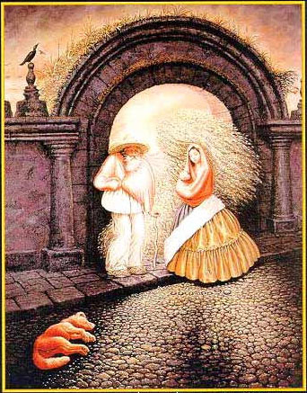
Who is the tallest?
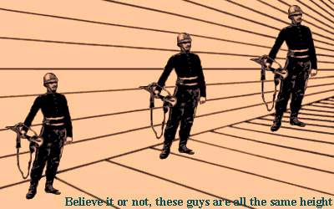
A face? ... Or, the word 'liar' ?
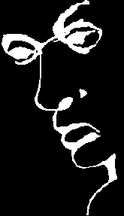
NEXT:
What do you see here?
Do you see the word "LIFT"?
Or, a bunch of black splotches ?

GIRLS ARE ABLE TO SPOT THE WORD "LIFT" EASILY.
MEN FIND IT DIFFICULT TO SEE THE WORD "LIFT"!!!

NEXT? FIND THE FACES:
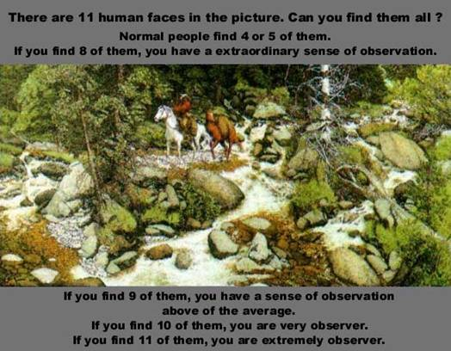
THE LAST ONE: FOCUS ON THE DOT!
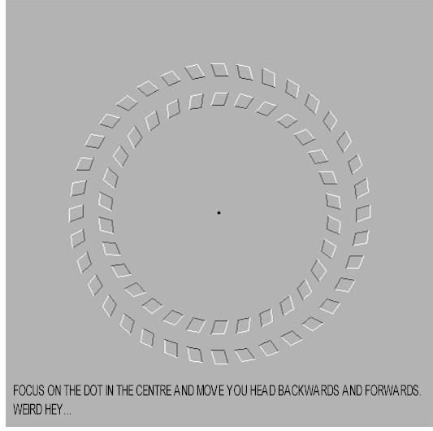
WHAT HAPPENED TO THE OBJECT?
THIS WAS COOL!!! PASS IT ON

