The US government has a new website, http://www.ready.gov.
The thing is that the pictures from the site are so ambiguous they could mean anything! Here are a few interpretations.

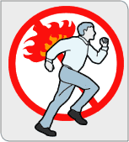
If you have set yourself on fire, do not run

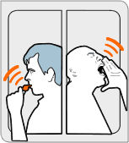
If you spot terrorism, blow your anti-terrorism whistle. If you are Vin Diesel, yell really loud.

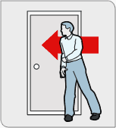
If you spot a terrorist arrow, pin it against the wall with your shoulder

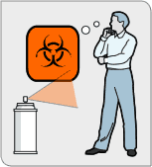
If you are sprayed with an unknown substance, stand and think about a cool design for a new tattoo.

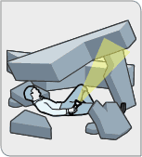
Use your flashlight to lift the walls right off of you!

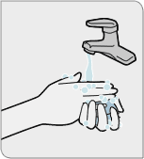
The proper way to eliminate smallpox is to wash with soap, water and at least one(1) armless hand.

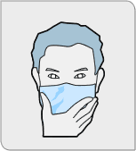
Michael Jackson is a terrorist. If you spot this smooth criminal with dead, dead eyes, run the hell away.

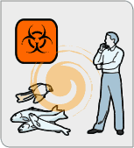
Hurricanes, animal corpses and your potential new tattoo have a lot in common. Think about it.

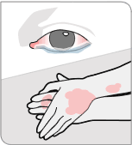
Be on the lookout for terrorists with pinkeye and leprosy. Also, they tend to rub their hands together manically.

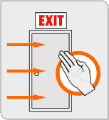
If a door is closed, karate chop it open.

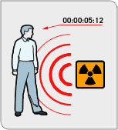
Try to absorb as much of the radiation as possible with your groin region. After 5 minutes and 12 seconds, however, you may become sterile

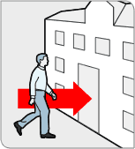
After exposure to radiation it is important to consider that you may have mutated to gigantic dimensions: watch your head.
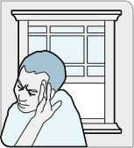
If you've become a radiation mutant with a deformed hand, remember to close the window. No one wants to see that shit.

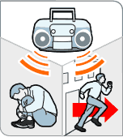
-- If you hear the Backstreet Boys, Michael Bolton or Yanni on the radio, cower in the corner or run like hell.

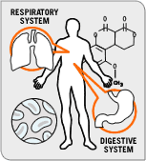
If your lungs and stomach start talking, stand with your arms akimbo until they stop.

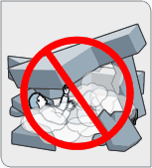
If you are trapped under falling debris, conserve oxygen by not farting.

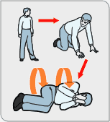
If you lose a contact lens during a chemical attack, do not stop to look for it.

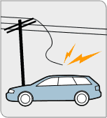
Do not drive a station wagon if a power pole is protruding from the hood.

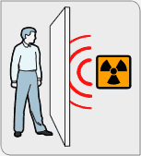
-- A one-inch thick piece of plywood should be sufficient protection against radiation.

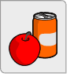
Always remember to carry food with you during a terrorist attack. At least you'll be able to enjoy a nice coke and apple before you die.

